Project Development Phase Model Performance Test

Date | 01 October 2026
Team ID | SWTID-2026-2085
Project Name | Import Data using Transform Maps (Spreadsheet)
Maximum Marks

Model Performance Testing:
Project team shall fill the following information in model performance testing template.

S.No. |  | Parameter |  | Description |  | Values |  | Screenshot
1. |  | Model Summary |  | Brief summary of what the model does and how it is set up, including the data it uses and the objects, fields or reports involved. |  | - |  | 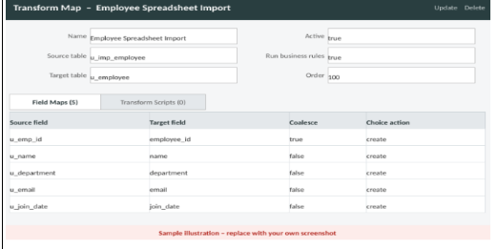
2. |  | Accuracy |  | Measures how |  | Training |  | 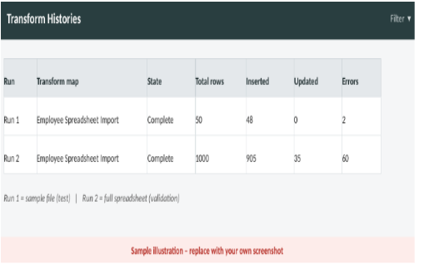
 |  |  |  | often the model |  | Accuracy -
 |  |  |  | predicts |  | Validation
 |  |  |  | correctly. |  | Accuracy
 |  |  |  | Training
 |  |  |  | accuracy is
 |  |  |  | measured on the
 |  |  |  | data the model
 |  |  |  | learned from;
 |  |  |  | validation
 |  |  |  | accuracy is
 |  |  |  | measured on
 |  |  |  | unseen data to
 |  |  |  | check how well
 |  |  |  | the model
 |  |  |  | generalises.
 | 3. |  |  |  | Result after fixing the errors (cleaning the data, correcting field maps, setting Coalesce) and re-importing. |  | After fixing the errors and importing the file again, the accuracy improved to 99.5%. | 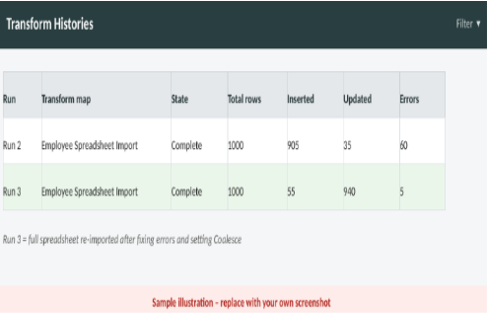
  Fine Tuning

